**Banner Self Service Query Instructions**

In ulink, select My Finance Query on the Financial Resources card:

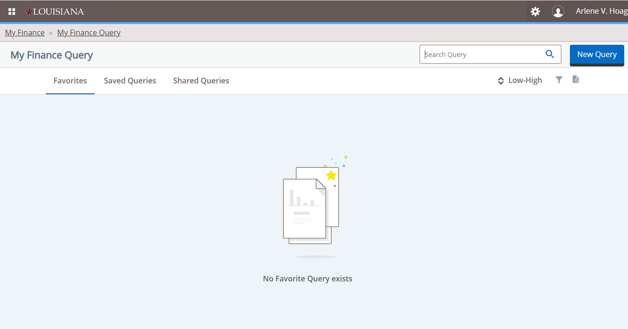

New query

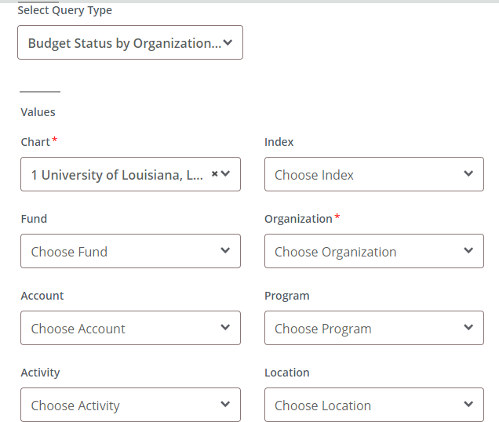

Choose Budget Status by Organizational Hierarchy Chart – 1

Enter fund (organization defaults) – don’t select any other field

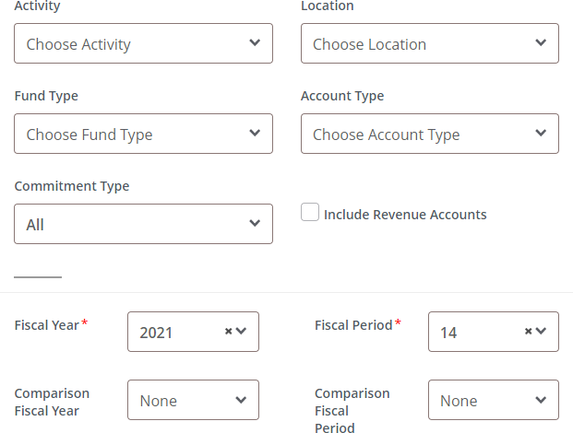

2026

**The new Self Service doesn’t allow for the 70 account type. **

Populate Fiscal year and fiscal period

Comparisons are none and none

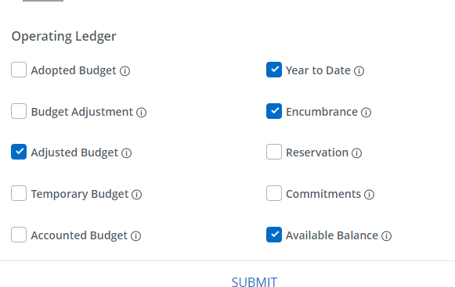

Selected check boxes and submit

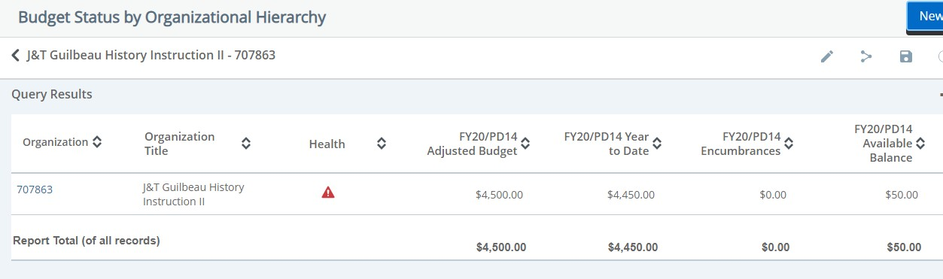

Select your organization to see the detail

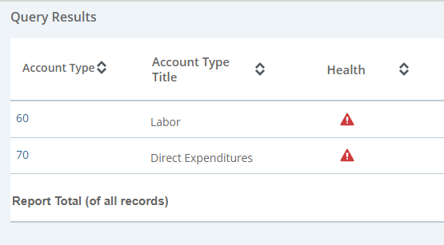

The detail for 70 is your discretionary budget/activity. All professorships and chairs are budgeted as 71 for carryover and 72 for current year discretionary.

If you hire students, GA’s etc, you will need to reduce the balance available in the Account type 70 by the applicable charges showing in 60.

To save your query

Make sure your query is showing the organization only. (Like the old self service, once you drill down, it remembers the settings for the next time.)

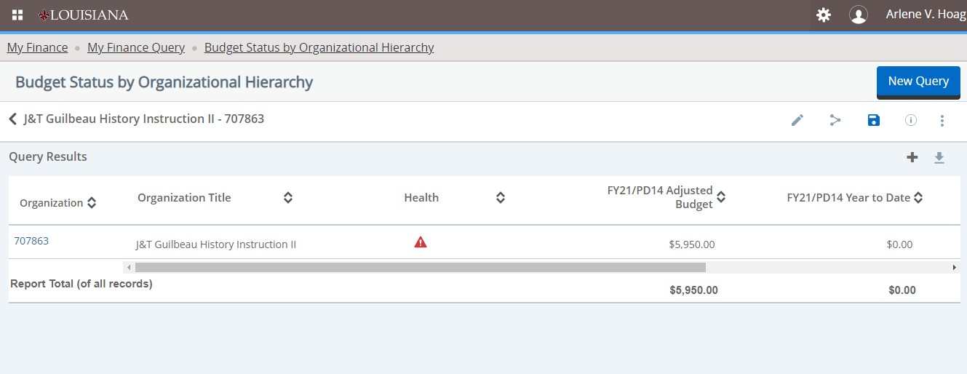

Name it

To pull up a balance for a saved query on a fund

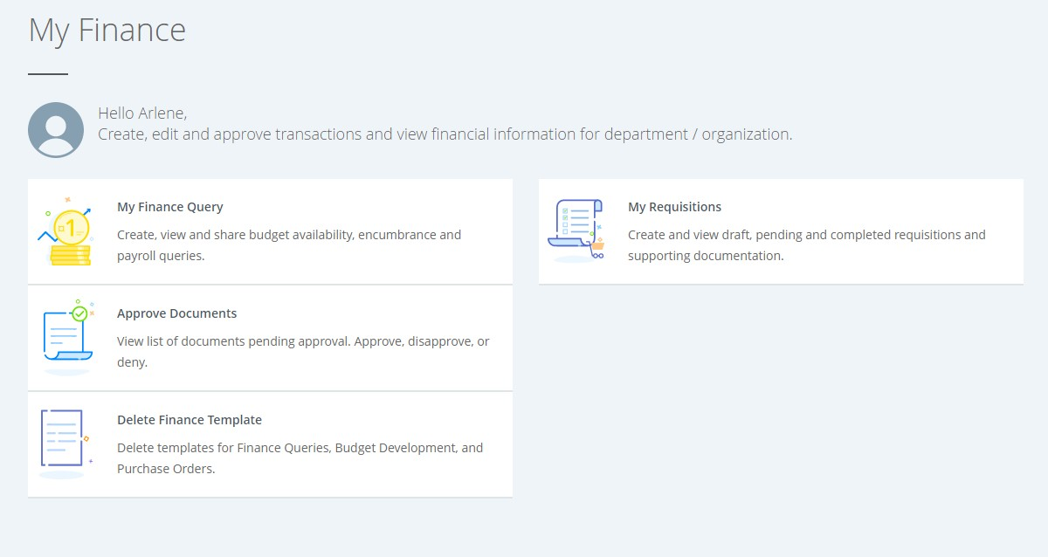

Select My Finance Query

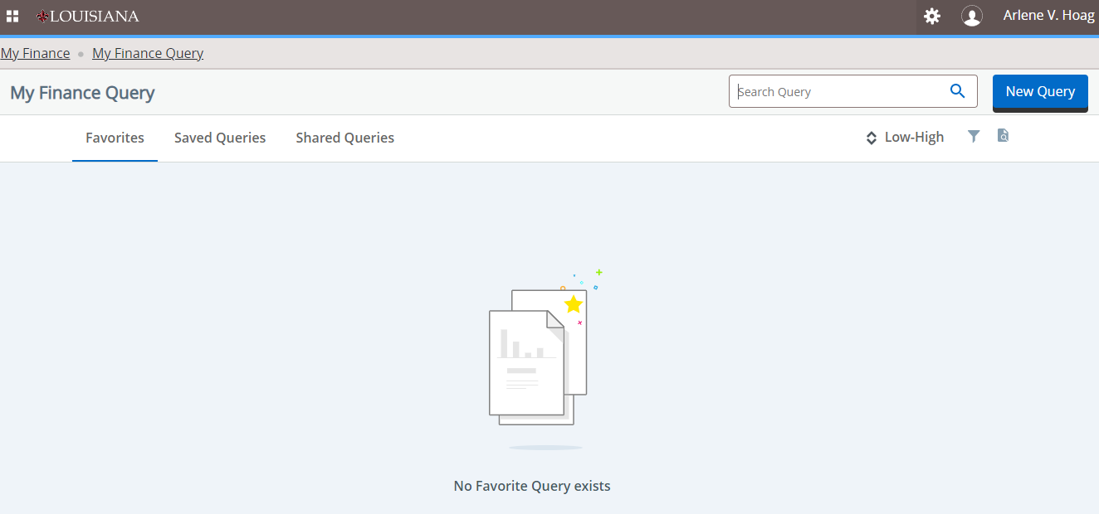

Select Saved Queries

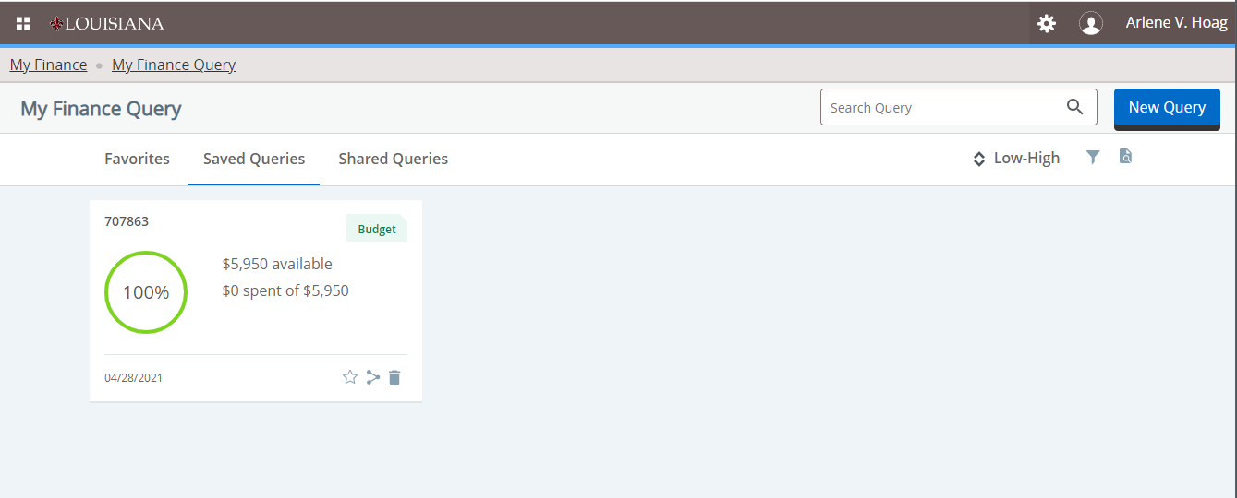

Select your query Select the organization Select 70